

**EMERGENCY**

**MANAGEMENT**

**PLAN**

**2024**

**CONTENTS**

**Introduction…………………………………………………………………………………………………………………. 3**

**Non- Site Emergency Contacts …………………………………………………………………………………….. 4**

**Site Emergency contacts………………………………………………………………………………………………..5**

**Incident Response Group……………………………………………………………………………………………… 6**

**Incident Response Group contacts…………………………………………………………………………………7**

**Site Profile……………………………………………………………………………………………………………………..9**

**Site Plans and Area Maps……………………………………………………………………………………………..11**

**Emergency Assembly Areas and Alarm Tone Procedures………………………………………………13**

**High Risk Emergency Procedures…………………………………………………………………………………. 16**

**After hours shutdown procedure ………………………………………………………………………………… 17**

**Emergency Supplies Plan……………………………………………………………………………………………… 18**

**Student Collection Protocol…………………………………………………………………………………………. 19**

**Administrative Support Plan………………………………………………………………………………………… 20**

**Unit Safety Reps and Proxy …………………………………………………………………………………………..22**

**Completion Checklist …………………………………………………………………………………………………… 23**

*Appendix A1 – Incident Controller (Emergency Procedure)…………………………………………………24*

*Appendix A2 – Incident Controller (Post Emergency Procedure)………………………………………….25*

*Appendix B1 – Operations Controller (Emergency Procedure)……………………………………….……26*

*Appendix B2 –Operations Controller (Post Emergency Procedure)………………………………………27*

*Appendix C1 – Communications Officer (Emergency Procedure)…………………………………………28*

*Appendix C2 – Communications Officer (Post Emergency Procedure)………………………………..29*

**Emergency Management Plan (abridge)**

**INTRODUCTION**

In accordance with the principles of the *Work Health and Safety Regulations 2012* under the *Work Health and Safety Act 2012* and Australian Standard, Planning and Emergencies in Facilities AS3745-2010**, each Department of Education site must have a site Emergency Plan in place.**

The purpose of this template document is to ensure a minimum standard of considerations in responding to an emergency or other major incident at a DfE site and should ideally be completed by a member of your Emergency Management Team, Incident Response Group or suitably experienced individual.

**Once complete, your site Emergency Management Plan is to be submitted** to the Security and Emergency Management unit at [DECD.SecurityIncident@sa.gov.au](mailto:DECD.SecurityIncident@sa.gov.au) within DfE Central Office, Adelaide for audit and compliance as per the listed requirements within the Site Reporting Companion and mandated by the *Emergency Management Framework*.

Please note that scope of the internal audit is:

1. To confirm the existence of an approved *Emergency Management Plan* at each site
2. To confirm that all areas of the template have been completed
3. To confirm that *distinctly different notification tones or systems* exist for the various emergency response options to ensure evacuation alerts and shelter in place alerts are not misinterpreted

The Security and Emergency Management unit cannot accurately assess the quality or viability of the specific processes you document for your Incident Response Group, since they must be tailored specifically to your infrastructure, occupancy and staffing.

You are required to undertake a minimum of two (2) emergency simulations per term, which should be used to openly and honestly assess the likely success or failure of your processes. Where necessary, changes should be made to ensure any deficiencies are adequately addressed.

The Security and Emergency Management unit can provide advice to assist you in the development or amendment of your emergency plan.

As the site Emergency Management Plan must be checked for currency at least once per year, the Security Emergency Management unit will ensure the online availability of any updated versions of this template by 31st May each year. Note – you will only be required to complete new sections of the template, not the whole document.

**Please note that all updated and completed plans are to be submitted prior to 31st July each year.**

***Completion and submission of this template supersedes any pre-existing site emergency templates and any prior displays of emergency contact information must be consistent with the information contained within this document***

**NON – SITE EMERGENCY CONTACTS**

|  |  |
| --- | --- |
| **Emergency (Police, Fire, Ambulance)** | **000** |
| **Police** | **13 1444** |
| **Local Police** | **8207 9411** |
| **Local Fire** | **000** |
| **CFS Bushfire Information Hotline** | **1800 362 361** |
| **DECD Security & Emergency Hotline** | **8116 9230** |
| **State Emergency Service (SES)** | **13 2500** |
| **SA Power Networks** | **13 1261**  **82821545** |
| **Local Hospital – Lyell McEwin** | **8182 9000** |
| **Education Director – Kristen Masters** | **8314 4042** |
| **DECD Security, Bushfire & Emergency Team** | **1800 000 279** |
| **DECD Media Unit** | **8226 7990** |
| **SafeWork SA** | **1300 365 255** |
| **Environmental Protection Authority** | **8204 2004** |
| **Alcohol & Drug Information Service / Needle Clean Up Hotline** | **1300 131 340** |
| **Poisons Information Centre** | **13 1126** |

**SITE EMERGENCY CONTACTS**

**In the table below, list personnel situated at the site, who may be contacted in the event of an emergency situation impacting upon your site.** Considerations should be given to the inclusion of details for persons/groups likely to be using the site outside of normal business hours, eg OSHC, sporting activities etc.

|  |  |  |  |
| --- | --- | --- | --- |
| **Site Role / Position** | **Name** | **Contact Number**  **School** | **Out of Hours**  **Contact Number** |
| Principal | Cam Wright | 82542625 | 0417948552 |
| Deputy Principal | Danica Wuttke | 82542625 | 0407631314 |
| Assistant Principal | Kylie Scott | 82542625 |  |
| Senior Leader | Tenielle Fryer | 82542625 |  |
| Business Manager | Vera Pozniak | 82542625 |  |
| OSHC / Vac Care  School Holidays |  |  | 0459988101  82002516 |

**INCIDENT RESPONSE GROUP**

**STRUCTURE**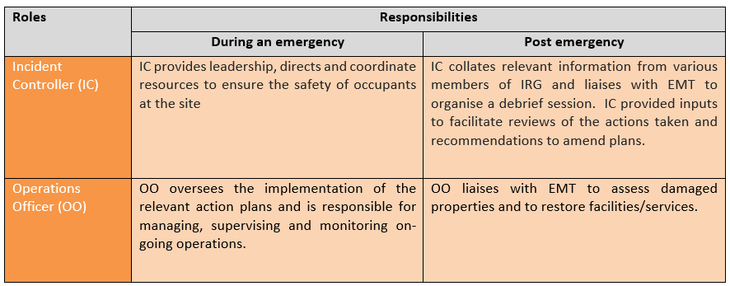



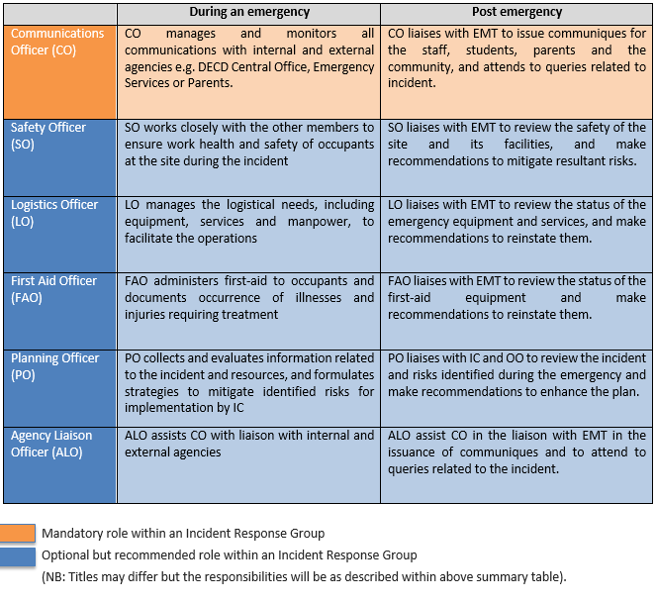

**INCIDENT RESPONSE GROUP CONTACTS**

Fill in the names and contacts of the main and alternate persons nominated for the respective roles in your Incident Response Group:

|  |  |
| --- | --- |
| Incident Controller | |
| Main: | Cam Wright |
| Contact: | 0417948552 |
| Alternate: | Danica Wuttke |
| Contact: | 0407631314 |

|  |  |
| --- | --- |
| Operations Officer | |
| Main: | Vera Pozniak |
| Contact: | 82542625 |
| Alternate: | Kylie Scott |
| Contact: | 82542625 |

|  |  |
| --- | --- |
| Communications Officer | |
| Main: | Danica Wuttke |
| Contact: | 0407631314 |
| Alternate: | Kylie Scott |
| Contact: | 82542625 |

|  |  |
| --- | --- |
| Safety Officer | |
| Main: | Ashlee Barnes |
| Contact: | 82542625 |
| Alternate: | Cam Wright |
| Contact: | 0417948552 |

|  |  |
| --- | --- |
| Logistics Officer | |
| Main: | Ruchi Mathur |
| Contact: | 82542625 |
| Alternate: | Vicki Jasson |
| Contact: | 82542625 |

|  |  |
| --- | --- |
| First Aid Officer | |
| Main: | Vicki Jasson |
| Contact: | 82542625 |
| Alternate: | Ruchi Mathur |
| Contact: | 82542625 |

|  |  |
| --- | --- |
| Planning Officer | |
| Main: | Kylie Scott |
| Contact: | 82542625 |
| Alternate: | Danica Wuttke |
| Contact: | 0407631314 |

|  |  |
| --- | --- |
| Agency Liaison Officer | |
| Main: | Kylie Scott |
| Contact: | 82542625 |
| Alternate: | Vera Pozniak |
| Contact: | 82542625 |

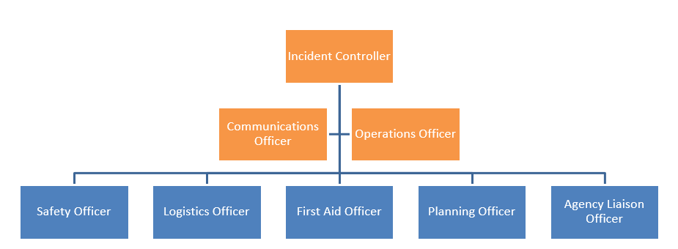

**INCIDENT RESPONSE GROUP ROLES**

|  |  |
| --- | --- |
| **Incident Controller** | IC directs and coordinates staff and students to safely exit areas. IC provides backup for an issues and ensures areas are evacuated. IC then moves to evacuation point to ensure staff and students are accounted for. |
| **Communications**  **Officer** | CO proceeds to the evacuation point. Ensuring staff and students are moving into their designated area. Assists the IC with the management of the ongoing operations. |
| **Operations**  **Officer** | OO proceeds to front of school to ensure no one enters school site.  Closes off gates to main area. Waits for the emergency vehicles to arrive and informs them of the area of emergency. Stays at front of school to inform anyone attempting to come on site of the emergency situation. Contacts IC or CO to communicate of emergency services attendance. |
| **Safety**  **Officer** | SO proceeds to evacuation point to ensure the work health and safety of staff and students on site during the incident. |
| **Logistics**  **Officer** | LO activates alarm for emergency. Prints off the report from academy sign in system. Collects the student emergency details folder. Locks the front doors to Admin building, then checks that all areas in admin are evacuated and closes doors behind and heads out to evacuation point |
| **First Aid**  **Officer** | FAO locates trolley with all relevant information and equipment and moves out to evacuation point. |
| **Planning**  **Officer** | PO proceeds to 2nd gate at front of school to ensure no one enters school site. Closes off gates.  Then proceeds to evacuation area to help with strategies to mitigate risks and liaise with internal and external agencies. |
| **Agency Liaison**  **Officer** | As above |

**All Officers have an alternate staff member in case of main contact being absent or not on site.**

**SITE PROFILE**

|  |
| --- |
| **SITE INFORMATION** |
| **Site Name** Adelaide North Special School |
| **Address** 135 Douglas Drive, Munno Para West SA 5115 |
| **Telephone** 8254 2625 |
| **Email** dl.0476.info@schools.sa.edu.au |
| **Time Site Opens** 8.00am |
| **Time Site Closes** 4.00pm |
|  |
| **STUDENT / STAFF INFORMATION** |
| **Number of Current Enrolments** 185 |
| **Number of Staff**  140 |
| **Proportion of Staff Disability/Health Factors (%)**  N/A |
| **Proportion of Student Disability/Special Education Needs (%)** 100% |

|  |
| --- |
| **BUILDING INFORMATION** |
| **Do you have a Monitored Security Alarm** Yes, it’s a combined security and fire   alarm system |
| **If “Other” make/model, provide details** N/A |
| **List Buildings NOT covered by security system** N/A |
| **Do you have a separate Fire Alarm Systems?** N/A |
| **List Buildings not covered by Fire Alarm** N/A |
| **Is there an emergency telephone?** No |
| **If “others” provide details** N/A |
| **Select method used for alert tone warnings?** Others |
| **If “others” provide details** Security device, megaphone, whistles |
| **List on-site hazards (e.g., Gas/pool chemicals) Location (e.g., Science lab, chemical unit** |
| 1. Medical Support – Oxygen Purple Unit – Building F |
|  |
| **EMERGENCY POWER SYSTEM** |
| **Please provide information below relating to the backup power supply available for use on your site in the event of an emergency (e.g., Generator)** Please include information such as where to access the supply, what system is connected to the supply and basic operational information.  **If not applicable, please type N/A. DO NOT LEAVE BLANK SPACES.** |
| **Location** N/A |
| **Systems connected** N/A |
| **Basic operating instructions or location of** N/A  **Hard copy operating instructions** |

|  |
| --- |
| **UTILITIES** |
| **Please provide basic information below3 regarding the main utility supplies connected to your site.** Include information such as how to locate, operate or witch off these utilities in the event of an emergency. |
| **Utilities Location of shutoff valve/switch Special Instructions** |
| Gas (Mains/Bottled) Douglas Drive (in front of school) N/A |
| Water Douglas Drive (in front of school) N/A |
| Electricity Mains switchboard located on Each building has own   wall of Gym walkway switchboard |
| Sprinkler System N/A |
| Heating System Ducted Air Conditioning All areas  Gym – Gas heating Ceiling mounted |

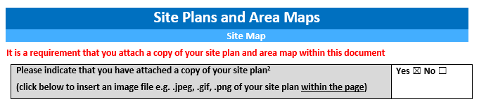

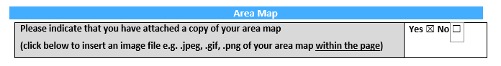

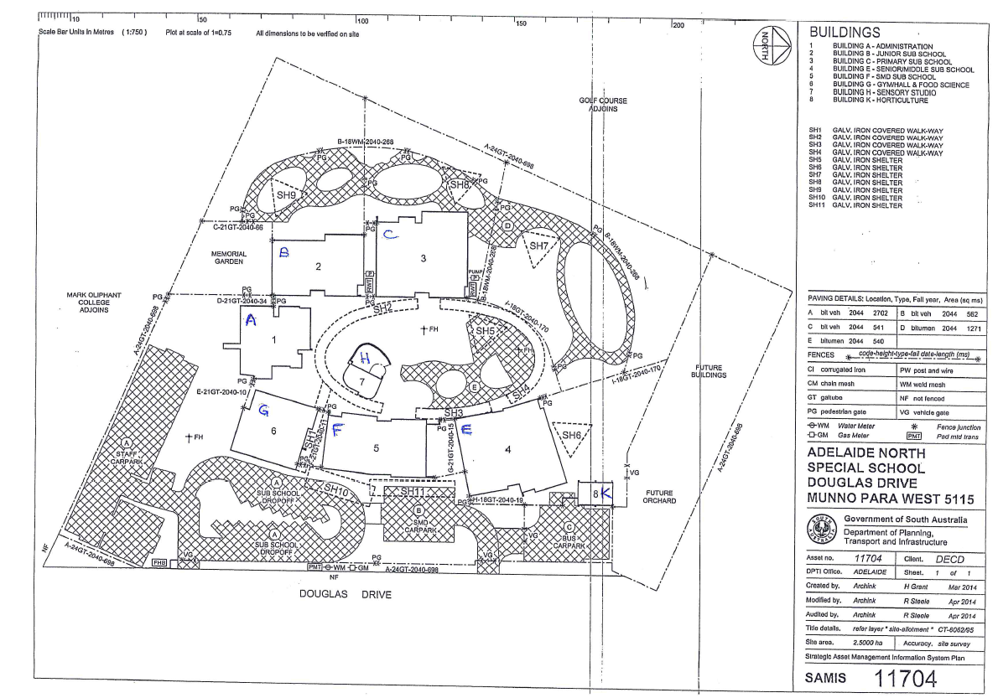

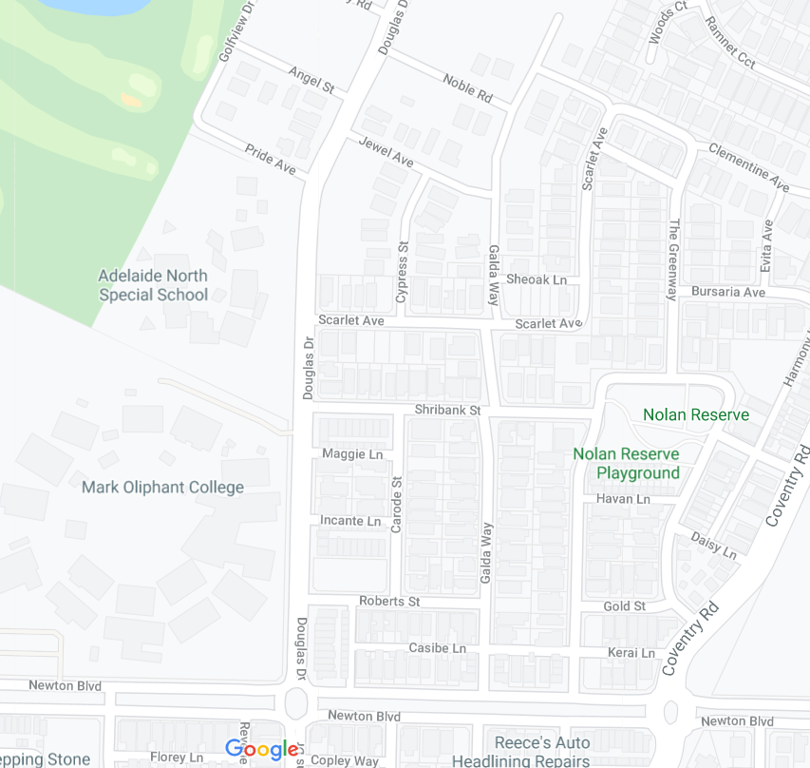

**EMERGENCY ASSEMBLY AREAS AND**

**ALARM TONE PROCEDURES**

IMPORTANT! The alarms raised for each emergency response should be easily distinguishable from each other. For example, an alarm tone and/or duration to direct persons to a Precautionary Building Confinement MUST differ from an alarm tone for an Evacuation response, in order to avoid any confusion

|  |
| --- |
| Emergency Assembly Areas & Alarm Tone Procedures |

Important! The alarms raised for each emergency response should be easily distinguishable from each other.   
For example, an alarm tone and/or duration to direct persons to a Precautionary Building Confinement   
MUST differ from an alarm tone for an Evacuation response, in order to avoid any confusion.

|  |
| --- |
| **Shelter-in-Place** |

Help! What is meant by Shelter-in-Place?

|  |
| --- |
| **Shelter-in-Place Location (specify SAMIS Building Number, room number or facility type)** |
| Not Applicable |
| **Alarm Tone/Alert Method Used Duration /Pattern of Alarm Tone (where applicable)** |
| N/A N/A |
| **If “Other”, please provide further details** |
| N/A |

|  |
| --- |
| Precautionary Building Confinement (PBC) / Stay in Place |

Help! What is meant by Precautionary Building Confinement (PBC)/Stay in Place?

|  |
| --- |
| **PBC / Stay In Place Location (specify SAMIS Building Number, room number or facility type** |
| All staff and students will go to the unit buildings and classrooms for invacuation. |
| **Alarm Tone/Alert Method Used Duration /Pattern of Alarm Tone (where applicable)** |
| Alarm – electronic Short continuous |
| **If “Other”, please provide further details** |
| Staff to lock all outside doors, if curtains are on windows, close them and everyone out of sight from any window or door. |

* **Leadership staff would be ringing unit reps if required.**

|  |
| --- |
| Evacuation |

Help! What is meant by an Evacuation?

|  |
| --- |
| **On-Site / Adjacent Muster Point Location(s) (e.g., oval/car park/courtyard)** |
| **On-Site Location A** Senior Active Yard |
| **On-Site Location B (optional)** Parent Car Park – southern area |
| **If there are two locations A & B, please state the protocol used to direct the occupants to either A or B during an emergency.** |
| All staff and students to go to the Senior Active Yard as first point. If there is any danger from emergency then staff and students should go to the Parent Carpark – southern area. |
| **Alarm Tone – Method Used Duration / Pattern of Alarm Tone** |
| Alarm – electronic Long continuous |
| **If “Other”, please provide further details** |
| In an emergency situation where staff and students need to evacuate the buildings, please take the shortest, safest path to the designated area. |

|  |
| --- |
| Off-Site Back-up Location |

Help! Why do I need an Off-site Back-up Location?

|  |
| --- |
| **Off-Site Back-Up Location(s)** |
| Off-site Location A Mark Oliphant College – if directed by Emergency Services |
| Off-site Location B (optional) Playford Lakes Golf Course – if directed by Emergency Services |
| **If there are two locations A & B, please state the protocol used to direct the occupants to either A or B during an emergency.** |
| A – In an emergency situation where staff and students need to evacuate the buildings, please take the shortest and safest possible route to the Mark Oliphant College tennis courts (through gate in staff car park) if directed by Emergency Services  B – If directed by Emergency Services, make your way to Playford Lakes Golf Course. Go through gate in the JP Playground which takes you through to a lane way to golf course. |
| **Alarm Tone / Method Used Duration / Pattern of Alarm Tone** |
| Alarm – electronic Long continuous |
| **If “other”, please provide further details** |
| N/A |
|  |

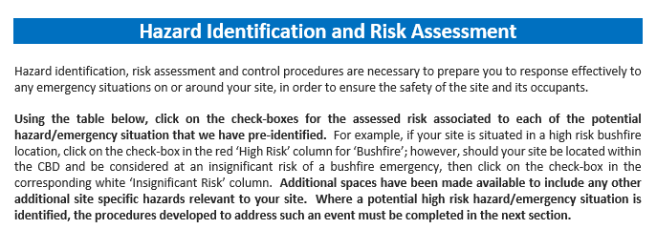

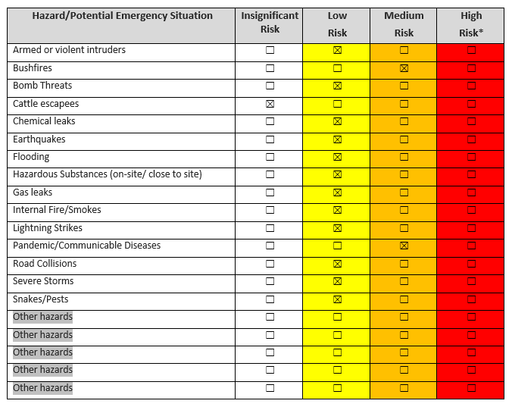



|  |
| --- |
| Hazard Emergency Response |
| Flood Off-site evacuation |
| Additional procedures |
| List additional procedures to complement those developed for your ‘Off-site evacuation’ procedures as stated in the earlier section of ‘Emergency Assembly Areas and Alarm Tone Procedures’. |

|  |
| --- |
| Hazard Emergency Response |
| Fire On-site evacuation |
| Additonal procedures |
|  |

|  |  |
| --- | --- |
| Hazard | Emergency response |
| Intruder | Stay in Place |
| Additional procedures |  |
|  |  |

|  |
| --- |
| Hazard Emergency Response |
| Bomb threat Off-site evacuation |
| Additonal procedures |
|  |

|  |
| --- |
| Hazard Emergency Response |
| Pandemic – School Shutdown COVID Shutdown |
| Additional procedures |
| Departmental Guidelines change weekly – for the latest updates please refer to intranet. |

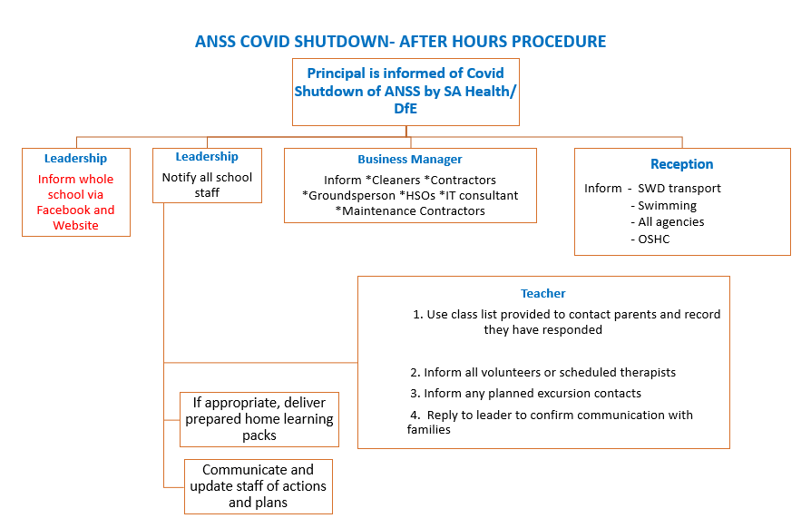

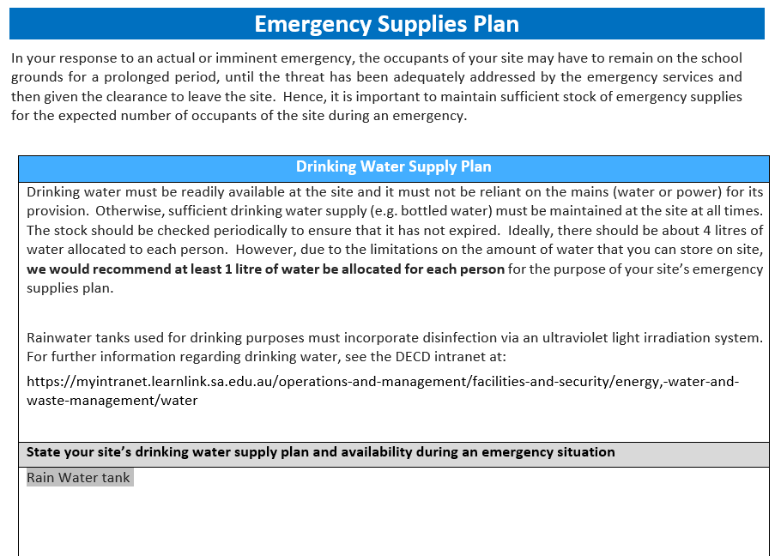

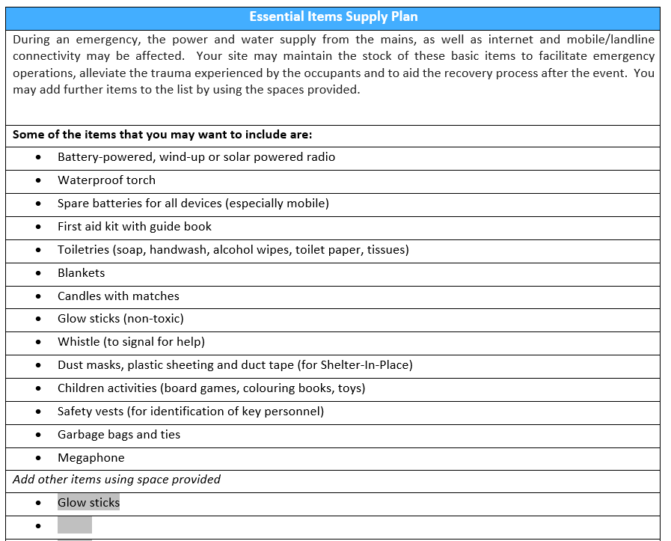

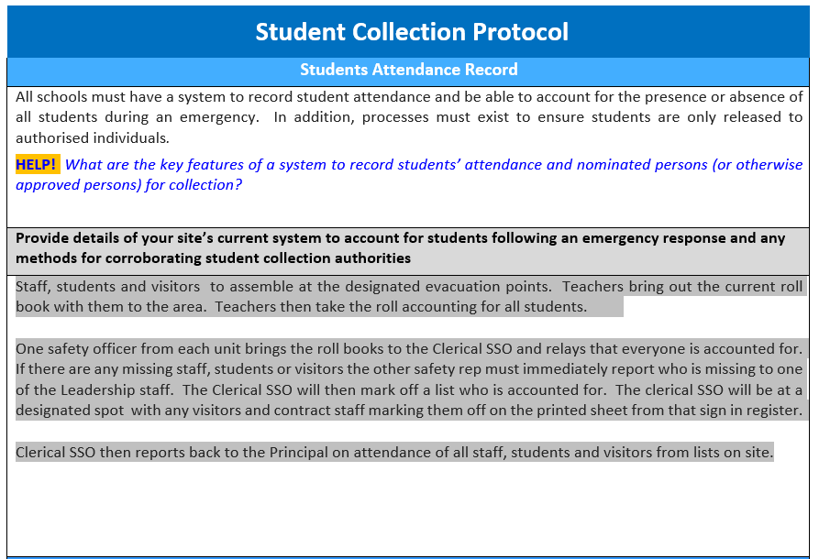

|  |
| --- |
| Student Collection During Emergency |
| Emergencies may occur at any time and often without warning. In such circumstances, it may not be possible for students to be collected by their usual family member or authorised person, or indeed be permitted to make their way home in the usual manner. Sites must ensure that adequate processes are implemented to facilitate urgent changes to usual collection or release arrangements (e.g., SMS authorities permitted and with agreed codeword, proactive communication to parents on Total Fire Ban days or during storm events, urgent OSHC arrangements).  HELP! *What are the guidelines in developing an effective student collection protocol during an emergency?* |
| **Detail any specific arrangements to accommodate urgent changes to collection / release authorities during an emergency.** |
| Parents and caregivers will be contacted to pick students up from the designated area. The Transport company will be contacted and advised of emergency situation and procedures regarding transport of students. Students who are unable to be picked up by parents/caregivers will stay with staff until arrangements can be made to be transported home. |

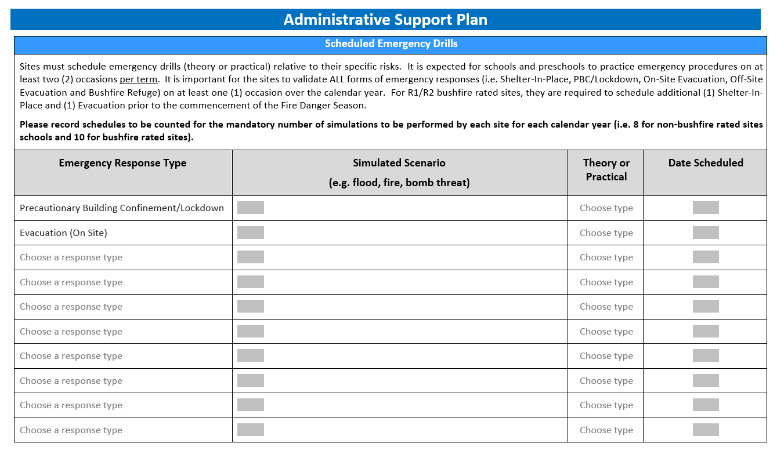

|  |
| --- |
| Designated First Aid Staff |
| Vicki Jasson 8254 265 |
| Ruchi Mathur 8254 2625 |
| Amanda Turner 8254 2625 |
| Leona Cox 8254 2625 |

|  |  |  |  |  |  |  |
| --- | --- | --- | --- | --- | --- | --- |
| Persons Requiring Additional Assistance Register | | | | | | |
| Please complete the below register with occupants that would require assistance in the event of an emergency situation i.e., those with special needs or disabilities. | | | | | | |
| Name | Location/Area | Condition | Type of assistance required during emergency | Name of responsible person for provision of assistance | Responsible person contact number |
| All students  Suzie Conniff | Whole School | Assorted  Wheelchair | Assorted | Cam Wright | 82542625  0417948552 |

WHS Officer & Fire Warden for Units

|  |  |  |
| --- | --- | --- |
| Unit | Work Health & Safety Officer | Fire  Warden |
| **Junior Primary Unit** | Ashlee Barnes | Sam Frankcom |
| **Primary Unit** | Alex Hazeal | Claire Palmer |
| **Pink Unit** | Kat Wcislo | Kayla Mancini |
| **Senior Unit** | Luke Stephenson | Joshua Fitzpatrick |
| **R – 12 Unit** | Peter Smith | Peter Smith |
| **Pathways** | Andrew Clark | Andrew Clark |
| **Grey Unit** | Natalie Costa | Ash Laoutaris |

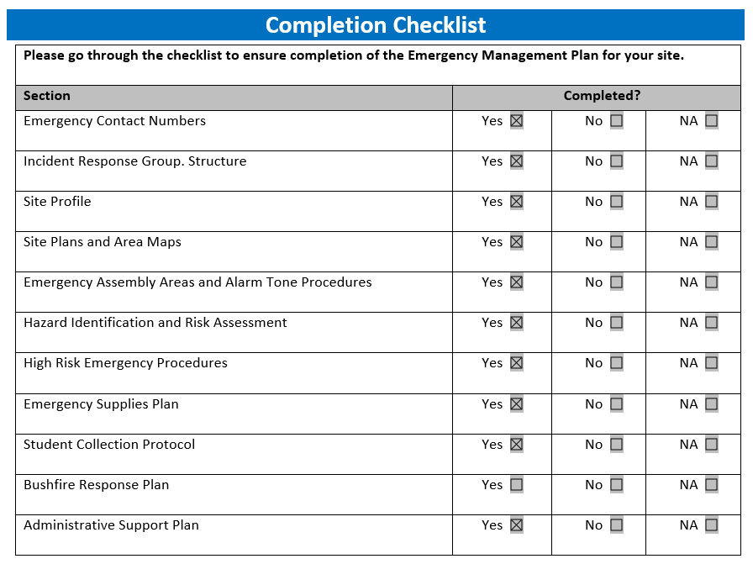

This Document is completed by:

|  |  |
| --- | --- |
| Name | Vera Pozniak |
| Designation | Business Manager / Operations Officer |
| Contact Number | 8254 2625 |
| Email | dl.0476.info@schools.sa.edu.au |
| Date of completion | 12/09/2024 |





